**Technical University of Munich**

Seminar on Data Analytics for Cybercrime and Undesirable Online Behaviors (IN0014)

Professorship of Cyber Trust (I-24)

Seminar Report

**Twitter’s handling of right-wing users**

Elisabeth Neumann, Clemens Schwarz

Examiner: Prof. Jens Grossklags, PhD.

**Statement of Proper Attribution, Originality of Work**

Elisabeth Neumann, Clemens Schwarz:

We hereby declare that we have prepared the present work independently without any non-trivial help of third parties and without use of other than the specified tools. The data, concepts and other contents acquired directly or indirectly from other sources are clearly indicated by the citation of the literature and appropriately highlighted in the text. The used materials from other sources do not constitute an unreasonable amount of our submitted work, i.e., well over 80% of the submitted work is written by ourselves. We are not reusing non-trivial portions of previous own work (e.g., previous seminar theses).

# Abstract

In the following thesis, we are giving an overview of our analysis on the German so-called „far-right“ Twitter-sphere, i.e. the collection of politically right-wing oriented users on the Twitter social network, and their interactions and behaviour. We collected data on several accounts basing our choice on a recently compiled list of known right-leaning users and profiles, publicized by Jan Böhmermann, a German satirist and television presenter.

We analyzed those tweets using a sentiment analysis script and tried to infer if the authors where reproducing right-wing propaganda, harassing media outlets or politicians, or exhibiting other unwanted behaviour generally associated with online „trolls“ or other forms of online harassment.

Following our data-collection and sentiment analysis, our next goal was to build so-called honeybots, automated scripts posing as regular users on twitter, which are meant to bait or provoke right-wing users/trolls into interacting with them, or to provoke Twitter support into banning them.

WIP; missing in Abstract: expected result/findings

# Introduction

In recent years, the political landscape in Germany has become more polarized, following the founding of the right-wing political party Alternative für Deutschland (alternative for Germany, in the following shortened to AfD) in 2013 and its movement to the far-right populist status it has as of the time of this writing. Especially after the AfD’s showing of support for the far-right extremist group PEGIDA („Patriotische Europäer Gegen Die Islamisierung Des Abendlandes“, patriotic europeans against the islamization of the occident) since 2015, the party has become more and more linked to and shown signs of racist, islamophobic, anti-semitic and xenophobic tendencies, positioning it as the currently most popular right wing party.

Following the shift to the political right in Germany and other Western-European states, more and more right-wing users have begun to pop up on Twitter, where they are both reproducing right-wing and alt-right propaganda and are also harassing left-leaning users such as politicians or media outlets, while exhibiting hateful and generally unwanted behaviours on the social network. As reporting those users to Twitter for their hateful messages rarely has any consequences, users on Twitter have begun to collect users exhibiting right-wing tendencies into lists, which one can use as blocklists, collections of users which can be collectively blocked and or muted, so that one would not see their tweets/interactions with other users anymore. Many of those people publish these lists so others can also block those people.

In the following we present the work of our thesis, in which we are trying to analyze the current atmosphere in terms of sentiment of German Twitter users, regarding tweets to certain topics or in response to other users. We are mainly basing our data-pool on a fairly extensive list of over 1400 right users, which was published by Jan Böhmermann, a German TV presenter and political satirist in May of 2018, and is also known as „Böhmermanns Schwarze Liste“, Böhmermann’s black list. He published this list as part of his anti campaign to the right movement of „Reconquista Germanica“.

After describing how we collected our data, we will explain how we began to analyze the tweets we found and how our sentiment analysis is conducted.

# The Data Collection Phase

While researching our topic we thought about different ways to find right-leaning users on Twitter. At first we did some hashtag analyses of recent important topics, such as „Flüchtlinge“, „Migrationspakt“ and „Gelbe Westen“. As we have seen in our first analysis it is very difficult to get the context in which tweets have been written and also the sentiment of the tweet or its author from just the text of the tweet without knowing the authors stand on the topic in question. Therefore we have narrowed down the user base from which we are pulling tweets to include in our data-base from anyone tweeting about a certain topic, to mainly analyzing users who have been included on Böhmermann’s black list and who have such been deemed „right trolls“, or who are outright right-wing politicians. The original authors of the black list stay anonymous, but sources around Böhmermann himself and his production company say, that a data analyst compiled the list from preexisting blocklists and wrote an additional algorithm, which added users who follow more than ten users from the right spectrum and who are also followed back by them.

Using this list seemed a good baseline from which to conduct our data collection. We first wrote an algorithm using the Twitter-API in order to weed out inactive or deleted accounts. For this, we wrote our own script in Python using the tweepy library. The Twitter API limited how fast we could pull users and confirm their activity status to about 65 users per hour, so in the end it took almost 2 days of the script running wo sort out about 300 users, which left us with about 1100 users to analyze.

Further testing showed that it was going to be much more efficient to just look at their most recent tweets, than to look at all tweets to a certain topic. We are limiting ourselves to a collection of 200 tweets per user, which still leaves us with more than 200.000 tweets, which are collected into a local database in which we are storing both our raw and processed data during our analysis.

# The Sentiment Analysis

After building our data base, we started to analyze the tweets on their sentiment, which means that we want to use an algorithm which categorizes tweets as inherently positive, negative or neutral. Using the German language extension of the textblob library in Python, we first looked at each tweet, cut the end of the word, so that only root words remained, which then could be matched to a list. The algorithm then assigned each word a numerical value corresponding to if it is positively, negatively or neutrally connotated. summing up the connotation-values of all words in a tweet, we can extrapolate the whole tweets sentiment, i.e. conclusively say if a tweet is rather positively or negatively connotated.

Given that we are pulling those tweets from a list of users, we now calculated for each individual user, which percentage of their tweets are positively, negatively or neutrally connotated.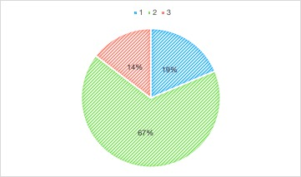

The following pie-chart shows the overall percentage of tweets and their connotations; about 14% of all collected tweets show negativ connotation (red), 19% show positiv connotation and the remaining 67% show neutral connotation.

The following line-chart shows the percentage of negatively connotated tweets in regards to all 1165 observed users, showing that while most users achieve only the average of 14,5% negatively connotated tweets, there are some significant exceptions, which we will look at specifically in detail.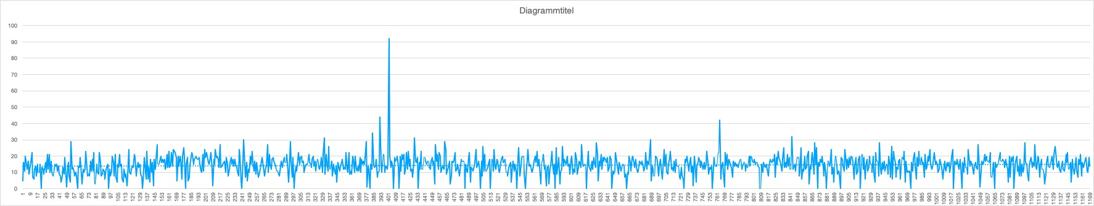

(Both charts are work in progress and will most likely undergo some sort of rework for better readability)

# Processing Data into WordClouds

Following the Sentiment Analysis, we sorted the data to only include users wich show an average of more than 30% negative or positive tweets for our next step in processing the data. We chose both very positive and very negative users in order to have two sets of groups to compare. Using the already reduced set of tweets where we cut off the endings from words so that only their roots remained for the sentiment analysis, we proceeded to visualize this data into WordClouds. These diagrams display the most used words graphically using different sizes and colors to indicate higher usage of a word in more tweets, and also how their connotation is valued by our sentiment analysis algorithm.

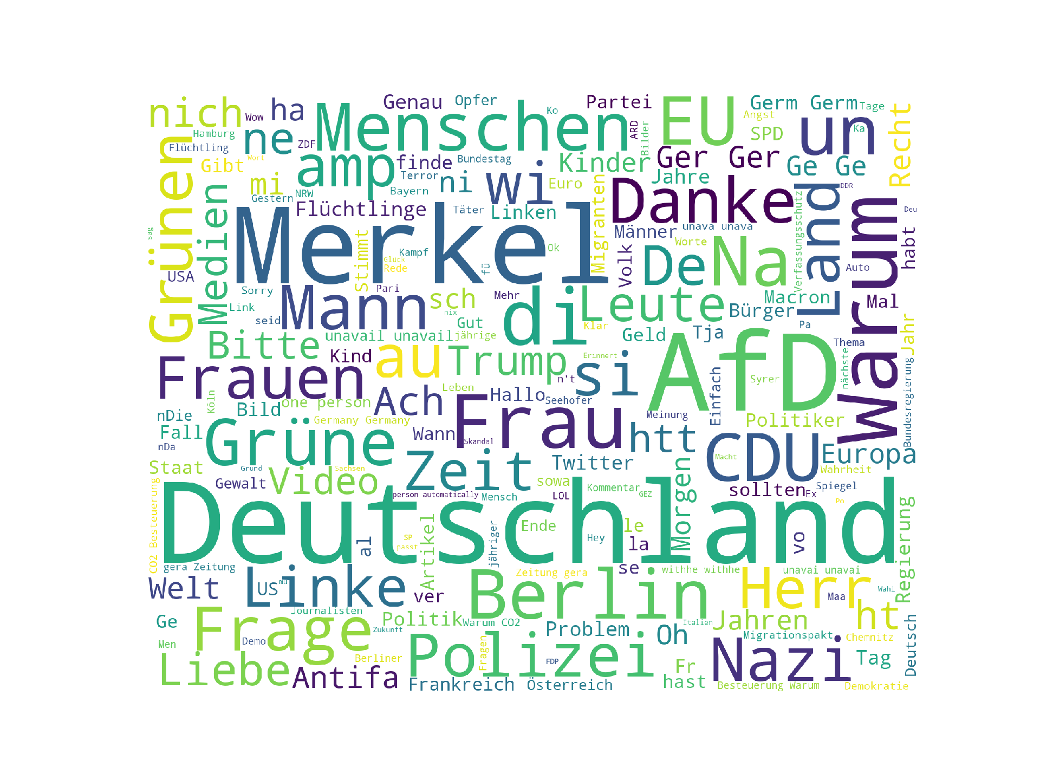

fig. 1, all nouns

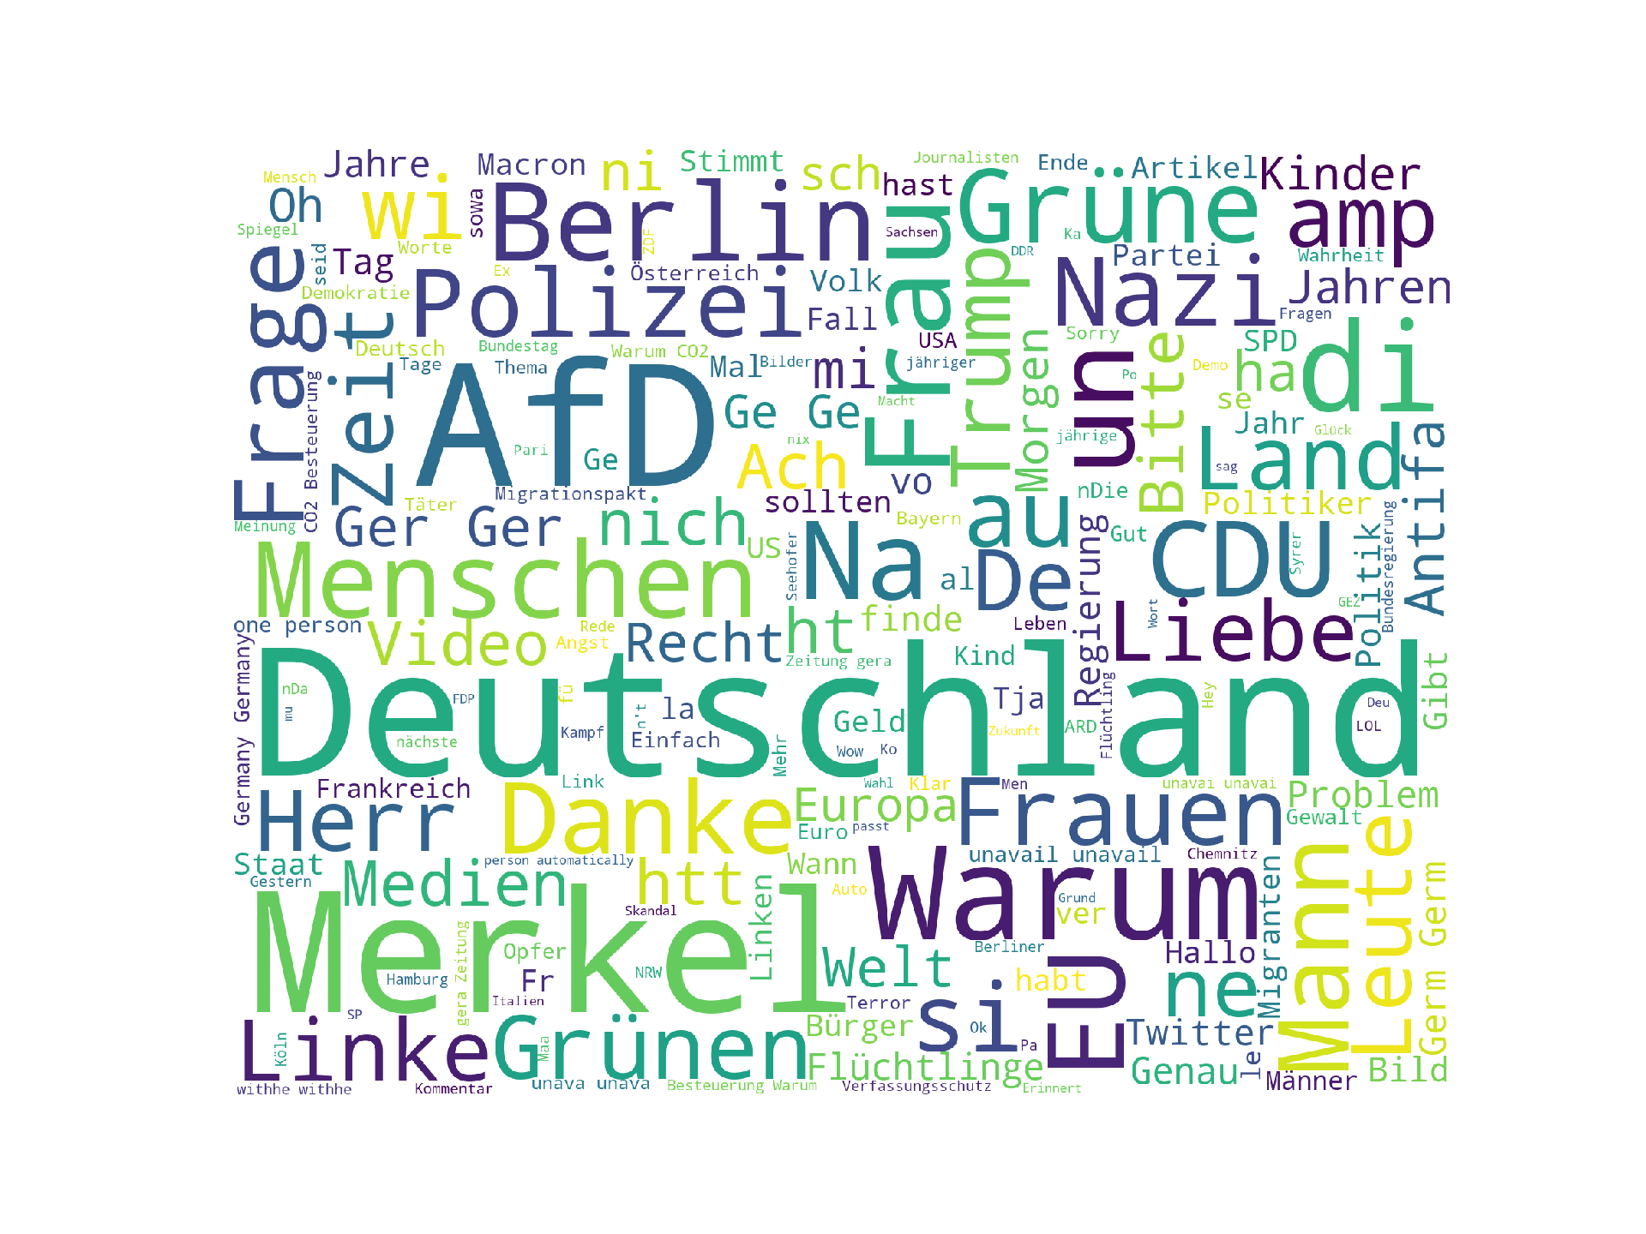

fig. 2, negative nouns

The above images show the final results of our algorithm. Figure 1 shows WordCloud for all collected nouns, while Figure 2 only displays all nouns collected from negative tweets into a WordCloud.

# Building Bots

By condensing all used nouns into these WordClouds, we can now begin to build our bots. These bots are built by firstly setting up a Twitter account and then letting a script take control over its behaviour on Twitter. The script not only determines how often the bot will tweet, but also what it tweets. By having built a database of often-used words in our data-collection and analysis phases, we can now directly use this database as a base for our bots database of phrases. We first give it a list of phrases to build sentences around the often-used words to make it seem more human, than just a straight-up bot.

An additional behaviour for the bots will be implemented to complete its function as a honey-bot: it will answer to tweets by certain popular twitter users in order to provoke them or their followers into interaction. Since we are trying to provoke right-wing users, we are setting the script up to check accounts related to the AfD-party, mainly their most prominent members. We are then observing both their performance as honey-bots (how much interaction are they able to provoke from other users?) and also how aggressive they have to be/appear, in order to even get reported to Twitter-support (will they more likely get banned from provoking right-wing users or by posing as a right-wing troll?)

# Analysis of bots, results

How long have they survived?

Which one lasted longer?

General behaviour: how many tweets, how much traction/interaction did they get/provoke

# Problems

To our surprise, most tweets are actually flagged neutral, which shows that either the algorithm is not harsh enough as to how the over-all sentiment of a tweet is calculated, or that the strategy of calculating a tweets connotational sentiment is flawed from the beginning, as a lot of context and subtext is missing when only looking at a single tweet.

Context also plays a big role in the over-all sentiment analysis, as we could easily observe, that while a lot of hateful content in tweets is being generated, many responses to negatively connotated tweets may be flagged as positively connotated, even though from context, the response is in agreement to the negative tweet, thus counting as a positive tweet.

Furthermore, the algorithm can not recognize rhetoric tools such as satire or cynicism.

# Bibliography

http://www.spiegel.de/spiegel/wahlkampf-mit-trollen-wie-die-rechten-im-netz-mobil-machen-a-1167063.html